0-25 SPECIAL EDUCATIONAL NEEDS AND DISABILITIES, ALTERNATIVE PROVISION AND ATTENDANCE UNIT
April 2019 Newsletter
Welcome to the April 2019 edition of the 0-25 Special Educational Needs and Disabilities (SEND), Alternative Provision and Attendance Unit Newsletter. In this Newsletter, we are focusing on:
Regional Stakeholder Network – volunteers requested
DfE consultation launched on post-16 qualifications at level 3 and below
Multi-million pound fund to train more Educational Psychologists in schools
Local Area SEND Inspection handbook update: ‘revisit programme’
Relationships education, relationships and sex education and health education
Realising the potential of technology in education
Improving the home learning environment in early years

Did you know that anyone could nominate someone for an Honour?
Research
- Ethnic disproportionality in the identification of SEN in England

Development Opportunities and Resources
- New resources to support post-16 providers to improve design and delivery of study programmes for learners with SEND
- SENCO Forum
- Anti-bullying support for schools
- The European Agency for Special Needs and Inclusive Education
- Autism Education Trust Resources
- Ambitious about Autism campaign
- Acquired Brain Injury: The hidden disability that teachers and SENCOs need to know about
Annex A: Relationships education, relationships and sex education (RSE) and health education
Annex B: Register as an early adopter: Relationships Education, Relationships and Sex Education (RSE) and Health Education

Regional Stakeholder Network – volunteers requested

The Office for Disability Issues is looking for people to join their new Regional Stakeholder Network. They require people who are keen to make a difference in nine regional groups across England: either as a Chair to lead and drive their group forward, or as a Member to share their views and experiences to help government make improvements.
The Regional Stakeholder Network will bring the views of disabled people, local disability organisations, and organisations that represent disabled people closer to government. It will create face-to-face forums and provide a channel for people to share their views about policies and services that affect them.
Further information on how to apply can be found at: Seeking chairs and members for the new disability Regional Stakeholder Network.
There is also a video on You Tube, which gives more information at: Regional Stakeholder Network. If you have any queries please email odi.contactus@dwp.gov.uk.
Applications should be completed and sent to ODI by 17 April 2019.

DfE consultation launched on post-16 qualifications at level 3 and below

The Government has launched a consultation on the review of post-16 qualifications at level 3 and below in England (EXCLUDING A LEVELS AND GCSES). The intention of this review, alongside the development of T Levels, is to build a world-class technical education system. The review is an opportunity to develop a qualifications system where every student, including those with SEND, benefit from high quality qualifications that help them realise their talents and achieve their career ambitions.
The consultation includes questions about qualifications generally, and also at level 3, level 2 and level 1 and below. We would like to encourage SEND stakeholders to respond to the consultation.
There are also two accompanying ad hoc statistical releases, which can be found here:
- Students and qualifications at level 3 and below in England
- Non-GCSE qualifications in England: key stage 4 entries and absence and exclusions outcomes

Please bring this consultation to the attention of anyone with a potential interest.

The consultation closes on 10 June, and further details can be found here Review of post-16 qualifications at level 3 and below in England.

Multi-million pound fund to train more Educational Psychologists in schools

Thousands of children across England will benefit from mental health and special needs support, as funding worth £31.6 million has been announced to train more Educational Psychologists.
The DfE has outlined plans to support more young people with additional educational needs by launching on 20 March 2019 a procurement exercise for experts to train more Educational Psychologists. The multi-million pound fund will see over 600 Educational Psychologist trainees receive free tuition and grants.
It follows the Education Secretary’s announcement in December last year to expand funding to increase the cohort of Education Psychologists from 160 to 206 each year.
Educational Psychologist workforce research shows that over two-thirds of councils surveyed in 2018 faced difficulties recruiting to fill vacant Educational Psychologist posts. In response to pressures faced by schools and councils, increasing the number of free places to train as an Educational Psychologist will ensure a steady flow of new entrants to the workforce and vary the geographical spread of training availability.

Local Area SEND Inspection handbook update: ‘revisit programme’

The Local Area SEND inspection handbook has been updated to include new arrangements for revisits to areas with a Written Statement of Action (WSoA) for SEND Local area SEND inspection: guidance for inspectors.
Revisits allow Ofsted and the Care Quality Commission to assess the progress local areas have made against each of the actions in their WSoA, as well as identifying where further work is needed and enabling local areas to demonstrate the improvements they have made.
Where a local area is considered to have made sufficient progress against all areas of the WSoA, formal support and challenge visits from the DfE and NHS England will cease. Where sufficient progress has not been made against all areas of the WSoA, DfE, the Department for Health and Social Care and NHS England will determine the next steps on a case-by-case basis – but this could include the Secretary of State using his powers of intervention.

Relationships education, relationships and sex education and health education

On 25 February, the Secretary of State laid the regulations and statutory guidance, in both Houses, for the introduction of:
- Relationships Education in primary school;
- Relationships and Sex Education in secondary school; and,
- Health Education in both primary and secondary state-funded schools.
The DfE is looking for your help in identifying schools to act as early adopters of this curriculum. They would begin teaching the new subjects from September 2019. We would be grateful if you could share this information with any of your stakeholders who you think this might be relevant to, or who might be able to become early adopters.
Further information can be found in Annex A and B at the end of this Newsletter.

Realising the potential of technology in education

The DfE has recently published the Education Technology (EdTech) strategy ‘Realising the potential of technology in education’. The strategy highlights the opportunities of technology, including the power of assistive technologies, to support increased function, motivation, independence and access to learning. This is DfE’s first step in supporting the education sector to overcome the barriers to embedding technology in an effective and efficient manner.
The strategy sets a number of 'EdTech challenges' to industry, the education sector and academia to prove what is possible and inform the future use of EdTech across our education system.
To help steer the work of this challenge and to help drive the agenda forward DfE will be convening a group of leading assistive technology developers and education experts.
Further information about the strategy can be found here Realising the potential of technology in education.

Improving the home learning environment in early years

We know that too many children still fall behind in their education early and it is hard to close the gaps that emerge. Last year, the Secretary of State for Education set an ambition to halve the proportion of children who finish their reception year without the communication, language and literacy skills they need to thrive.

Following a successful summit in November and the publication of a behaviour change model, we are developing a public facing campaign that encourages parents to chat, play and read more with their children, which we will be launching later this year. As we develop the campaign, we want to encourage all sorts of organisations to get involved and work together to ensure that all children have the early communication, language and literacy skills they need to succeed throughout their lives. We are keen to have SEND organisations as part of this. If you would like to register your interest to be involved please email: hle.coalition@education.gov.uk

We are also investing £6.5m in grants for voluntary and community sector organisations to work with families to support the home learning environment and children with SEND. Also, in collaboration with the Education Endowment Foundation, over £4m to trial projects in the north of England aimed at improving the home learning environment by providing practical tools and advice. We have also appointed an expert panel to develop criteria for quality-assuring early years apps and produce tips/guidance for parents on how to use apps to aid their children’s learning. We will be providing access to some of these high-quality apps free of charge to disadvantaged families with children aged two to four, in up to 12 pilot areas across the country.

Further information is available here Disadvantaged families to benefit from free early learning apps.

Did you know that anyone could nominate someone for an Honour?

Honours are a great way of recognising the achievements of ordinary people who do extraordinary things and are awarded to people:
- who have changed things especially by solid, practical achievement; and/or
- whose work has brought distinction to British life or enhanced the UK’s reputation in their area or activity.

This includes those who have made a real difference to children and young people’s lives. The person you nominate should still be actively involved in the field you are nominating them for, and should not know that they are being nominated.
The application process is straightforward, and can be completed online at Nominate someone for an honour or award .
If you would like to discuss any part of the process, please email shanaj.salah-uddin@education.gov.uk for further information.

Research

Ethnic disproportionality in the identification of SEN in England

New research published by Oxford University examines patterns of SEN identification for school-aged children in England. The report, which presents analysis of data from the National Pupil Database from 2005-2016, suggests that children of ethnic minority groups are over-represented for certain types of SEN and under-represented for other types. Key findings presented by the report include:
- Asian pupils (Indian, Pakistani, Bangladeshi and Other Asian) are half as likely to be identified with Autistic Spectrum Disorders as White British pupils, controlling for age, sex and socio-economic deprivation
- Black Caribbean and Mixed White and Black Caribbean pupils are twice as likely to be identified with Social, Emotional and Mental Health needs as White British pupils, controlling for age, sex and socio-economic deprivation

The research project also includes individual feedback reports for all LAs in England: these resources provide specific data on over and under-identification of SEN among ethnic minority groups in each LA. We do feel that these feedback reports will be particularly useful to LAs in considering issues of ethnic disproportionality and SEN provision in their local areas.
This research was conducted independently by the Department of Education at Oxford University, and was funded by the DfE through the Economic and Social Research Council Secondary Data Analysis Initiative.

Development opportunities and resources

New resources to support post-16 providers to improve design and delivery of study programmes for learners with SEND

Four new resources, developed by Natspec with the support of AoC, have been posted on the Excellence Gateway:
A leaflet on supported internships, which can be customised by individual providers for use in engaging employers, along with a downloadable, supported internship logo
A toolkit to help you co-create the curriculum with learners with SEND
A do-it-yourself CPD pack on making effective use of LSAs
A toolkit on using competition activity in the vocational curriculum with learners with SEND.

SENCO Forum

We are asking local authorities to bring The SENCO Forum to the attention of schools, early years settings, further education providers, SEND support services and, of course, SENCOs.

The Forum, now in its twenty-third year of operation, provides an opportunity for SENCOs and other SEND professionals to discuss issues and share information and practical advice. The Forum offers independent solution-based support in a collaborative and mutual way to both new-to-role and experienced SENCOs. The advice provided is based on the direct experience of SEND professionals, relevant research evidence and national/local policy guidance.
From 1 April 2019, the Forum moved to a new platform developed in collaboration with nasen and can be accessed via the SEND Gateway. Questions about using the Forum to disseminate information about SEND focused research, policy and practice can be addressed to The SENCO Forum Advisory Group Chair, Christopher Robertson, at: robertsoncml2@gmail.com.
Further information about the SENCO Forum can be found here SENCOs Area.

Anti-bullying support for schools

Bullying, for whatever reason, is unacceptable and we are continuing to support schools to tackle this important issue. Research shows that pupils with SEND report disproportionally high rates of bullying so we would encourage SENCOs and others to look at the following resources to better understand the support available.
Grant funding extended: Last year we announced an additional £1m of funding to extend our anti-bullying grants until March 2020. This includes continuing support to the Anti-Bullying Alliance who are extending their ‘All Together’ programme. Further details about the programme can be found here All Together: whole school programme for schools.
Respectful school communities’ tool: In November 2018, we published a self-review and signposting tool designed to support schools to develop a whole-school approach, which promotes respect and discipline. Further details can be found here Training school leaders.
Mental Health and Behaviour Guidance updated: We have published an update to our mental health and behaviour in schools advice. The updated advice will help schools to identify pupils whose behaviour may be a result of an underlying mental health difficulty, and direct them towards information about how they can adapt their approaches to support these pupils with their individual needs, within the context of an approach that is based on clear expectation of behaviour. Further details can be found here Mental health and behaviour in schools.

The European Agency for Special Needs and Inclusive Education

The European Agency for Special Needs and Inclusive Education is an independent organisation that acts as a platform for collaboration for the ministries of education in member countries. The Agency member countries’ vision is for inclusive education systems is that all learners of any age are provided with meaningful, high-quality educational opportunities in their local community, alongside their friends and peers.

The Agency has recently published a number of papers, these are:

Supporting Inclusive School Leadership: Literature Review this literature review aims to examine the available international and European literature (post-2012 and key literature published earlier) in order to identify key concepts underpinning policy and practice for inclusive school leadership, and agree operational definitions of key terms and concepts to be used during the project.

Supporting Inclusive School Leadership: Policy Review this review summarises recent international and European-level policy documents that are relevant to school leadership.

Analysis Framework for Mapping Inclusive Education Policies this document presents an analysis framework that has been developed to map inclusive education policies.

Autism Education Trust Resources

The Autism Education Trust (AET) continues to expand with a number of new training hubs across England joining the AET community to deliver the AET training in their designated Local Authority areas from 1 April 2019. There is great demand for the CPD certified autism training and associated resources to support educational settings and services (0-25) to develop their approach and provision.
If you are interested in accessing the training or becoming a training hub in your area, further details can be found here Autism Education Trust.
The AET is in the process of updating a number of its key resources, which are currently available on the AET website. The updated resources will be available later this year and include:
- the Good Autism Practice Research (originally commissioned in 2011)
- the popular Progression Framework (a tool to identify learning priorities and measure progress in areas which relate closely to autism differences)
- The Exclusions Service key documents.

To receive information regarding these updates, please sign up for the AET quarterly newsletter here Autism Education Trust.

Ambitious about Autism Campaign

Ambitious about Autism is running a campaign aimed at tackling loneliness among autistic young people. The charity’s youth patrons have created a series of ‘top tips’ outlining small changes in attitudes and behaviours that will help make autistic young people feel more included and accepted in different aspects of life.
The tips cover education, the workplace, youth groups and out and about in the community. The tips will be published weekly on the charity’s website where they can be downloaded and shared.
To request postcards of each set of tips, please email communications@ambitiousaboutautism.org.uk or to support on social media follow @AmbitiousAutism #IncludeAutism

Acquired Brain Injury: The ‘hidden’ disability that teachers and SENCOs need to know about.
It is estimated that the equivalent of one child per class will have experienced some kind of acquired brain injury (ABI) by the time they finish school. Despite this, many teachers report to knowing little about ABI and its implications for children and young people. Teachers should to be aware that an injury in childhood can lead to the emergence of new needs as the brain develops, so it is crucial that the ABI is not forgotten about as a child progresses through the school system.
Teachers and SENCOs can learn more through a range of excellent resources that are available:
- The Child Brain Injury Trust (CBIT) produce a range of resources and offer training courses (supported by the Eden Dora Trust) for teachers.
- Childhood Acquired Brain Injury: The hidden disability nasen and CBIT publication for teaching professionals
- Returning to education after a brain injury The Children’s Trust publication
- Supporting children after a stroke: Toolkit for teachers and childcare professionals the Stroke Association publication
- Education resources The Brain Tumour Charity
- Returning to school A teacher’s guide for pupils with brain tumours, during and after treatment A teacher’s guide for CYPs with brain tumours:
- Encephalitis in Children The Encephalitis Society
- Guidance for the post-discharge rehabilitation of children, adolescents and young adults with acquired brain injury The Eden Dora Trust
- All-party parliamentary group on acquired brain injury report ‘Time for Change: may also be of interest to education professionals. A national interest group (N-ABLES: National ABI in Education and Learning Syndicate) has been set up to address the report’s recommendations. If you are interested in joining and contributing to this group please follow @NABLES10 on Twitter, or contact info@ukabif.org.uk to join the mailing list.

We hope this newsletter reaches as many people and organisations as possible with an interest in SEND issues. Please feel free to pass it on to anyone who does not currently receive it and invite them to join our mailing list. However, if you no longer wish to receive this newsletter, please contact SEN.IMPLEMENTATION@education.gov.uk and we will remove you from our mailing list.

Annex A: Relationships education, relationships and sex education (RSE) and health education

Dear Colleagues
RELATIONSHIPS EDUCATION, RELATIONSHIPS AND SEX EDUCATION (RSE) AND HEALTH EDUCATION
On 25 February, the Secretary of State laid the regulations and statutory guidance, in both Houses, for the introduction of:
* Relationships Education in primary school;
* Relationships and Sex Education (RSE) in secondary school; and,
* Health Education in both primary and secondary state-funded schools.
The revised documents can be accessed here: Relationships (and sex) education and health education.
We continue to clarify these key messages:
- These subjects are for all pupils, including those with SEND and those in special schools, hospital schools and alternative provision.
- Schools have existing duties to provide access to high-quality teaching through a differentiated curriculum where necessary.
- We have also clarified wording on a Right to withdraw – as per the legal requirement, we are retaining the new proposed right, but have clarified how the decisions of head teachers should take into account SEND and how the decisions should be recorded.
School support
We are committed to supporting schools through training, further advice to improve practice and sharing of best practices from early adopter schools. We expect this to be a great opportunity to highlight effective practice for pupils with SEND.
The registration for the programme is now open and we are looking for schools that will start teaching the new requirements from September 2019. Schools that register now can participate in our user testing exercise that starts at the end of March. This exercise will test what teachers and schools want from a training programme and how the department can deliver it.
Information about the early adopter school programme and how schools can register is attached. You can send this information directly to your schools or use it in your conversations with them. If you have any questions about the registration process or the Early Adopter School Programme in general, please don’t hesitate to get back in touch with us. Schools can also contact us directly at rshe.earlyadopters@education.gov.uk.
We have announced a budget of £6 million in 2019-20 financial year to develop a programme of support for schools.
We will provide further advice to support schools to improve their practices and offer training that could be delivered using the latest technology, including opportunities for face to face training for teachers who might need it. We also intend to produce supporting information for schools on how to teach about all aspects of internet safety, not just those relating to relationships, sex and health, to help schools deliver this in a coordinated and coherent way across their curriculum.
The first debate on the regulations has now taken place in the House of Commons and the regulations were passed. The next stage will be debate in the Lords and the date for this is yet to be confirmed.
Many thanks for your support and hard work in helping us reach this point.
Jackie
Relationships Education/ Relationships and Sex Education / Health Education / PSHE team
Early Adopter enquiries: rshe.earlyadopters@education.gov.uk
General enquiries: RSE.PSHE@education.gov.uk

Annex B: Register as an early adopter: Relationships Education, Relationships and Sex Education (RSE) and Health Education
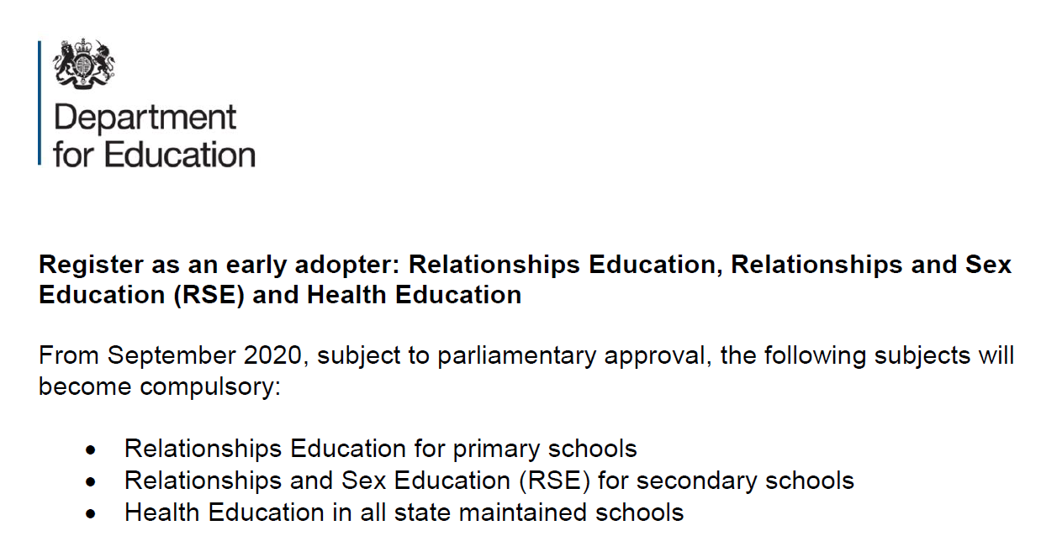
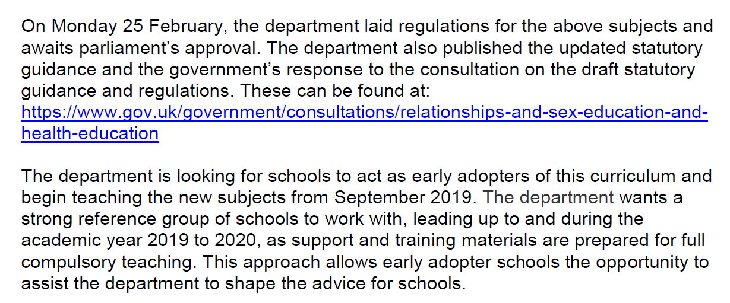
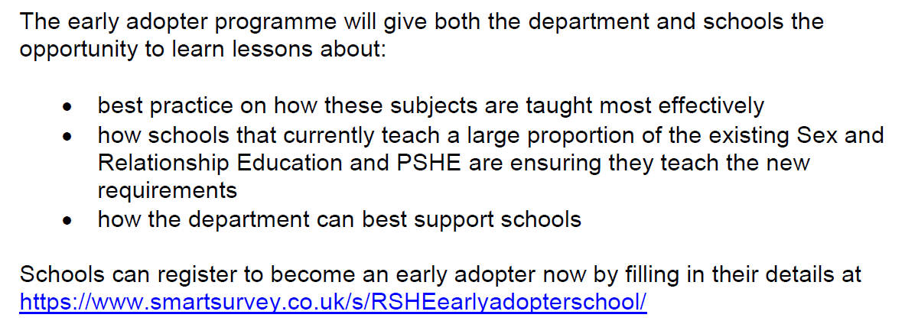

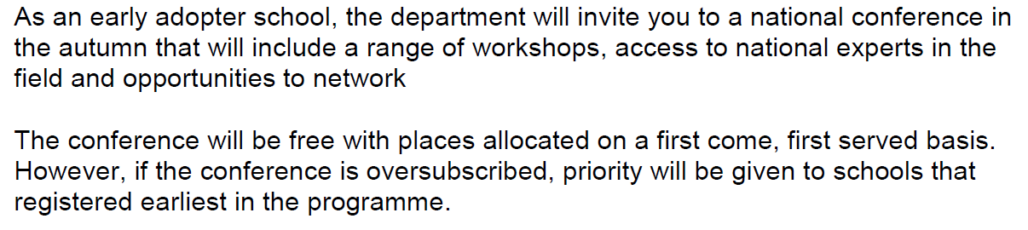
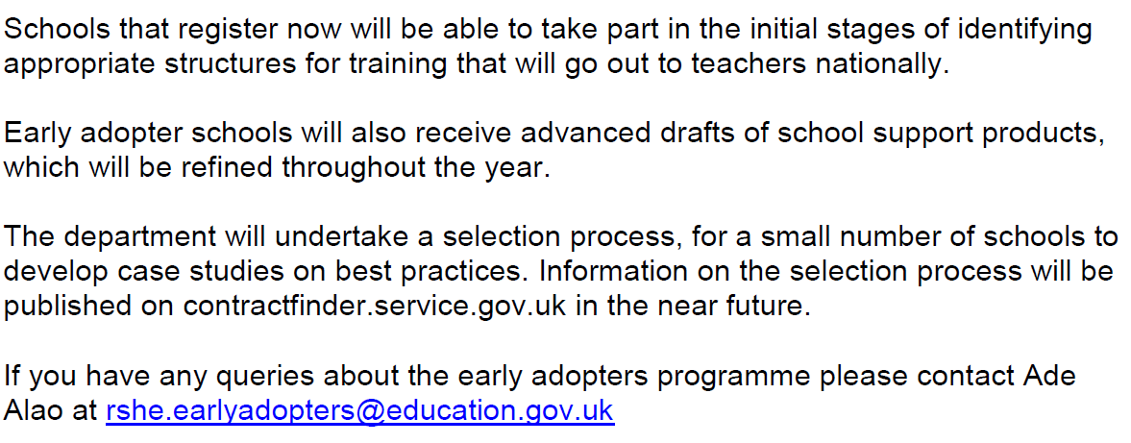
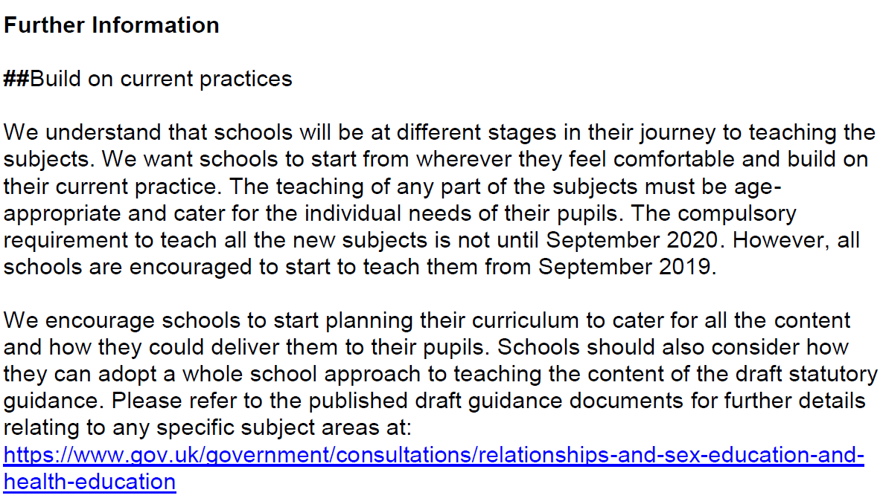
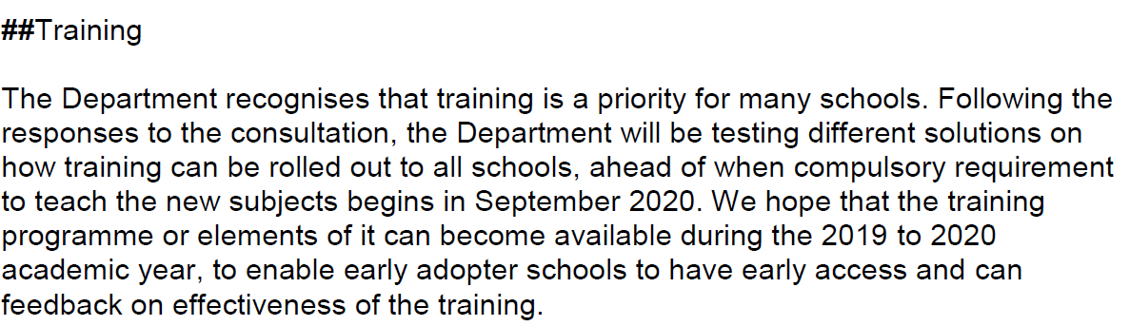
## Children and Social Work Act 2017
